Nalongsone Danddank Student ID : 14958950 StarID: jf3893pd

Email: [nalongsone.danddank@my.metrostate.edu](mailto:nalongsone.danddank@my.metrostate.edu)\

**ICS 432 - 01 — Distributed and Cloud Computing Fall 2021**

**Lab #2 :** Virtual Machines

Part 1: AWS.

Exercise 1: Virtual Machines in AWS: EC2.

**Lab report screen-shot #1:**

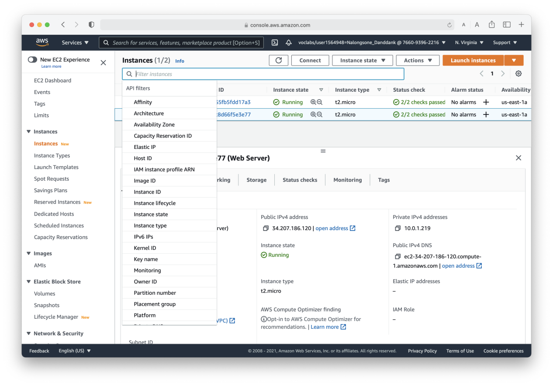

**Lab report screen-shot #2:**

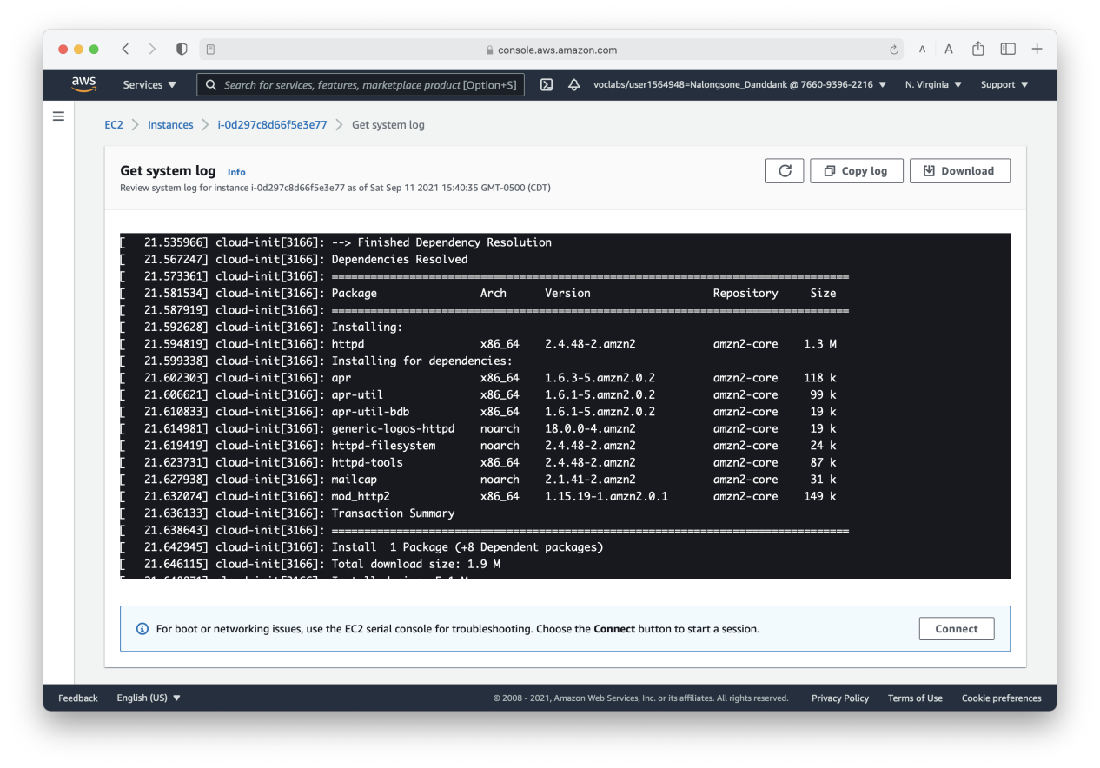

**Lab report screen-shot #3:**

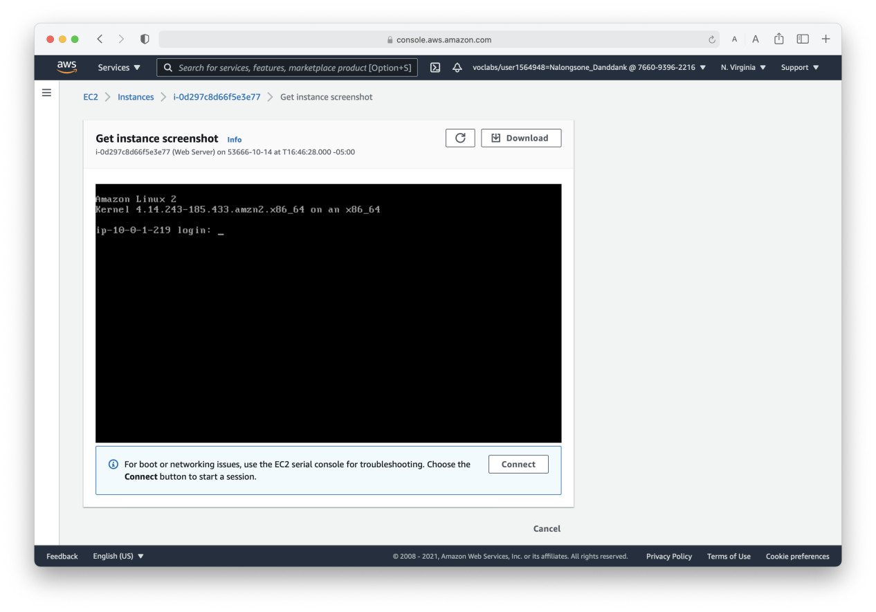

**Lab report screen-shot #4:**

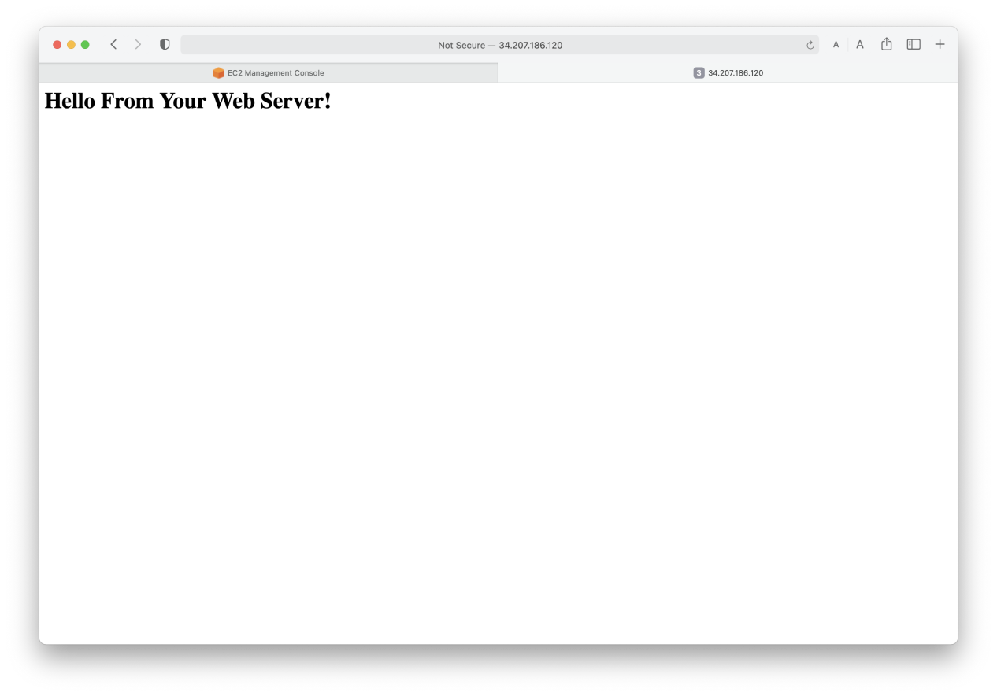

**Lab report screen-shot #5:**

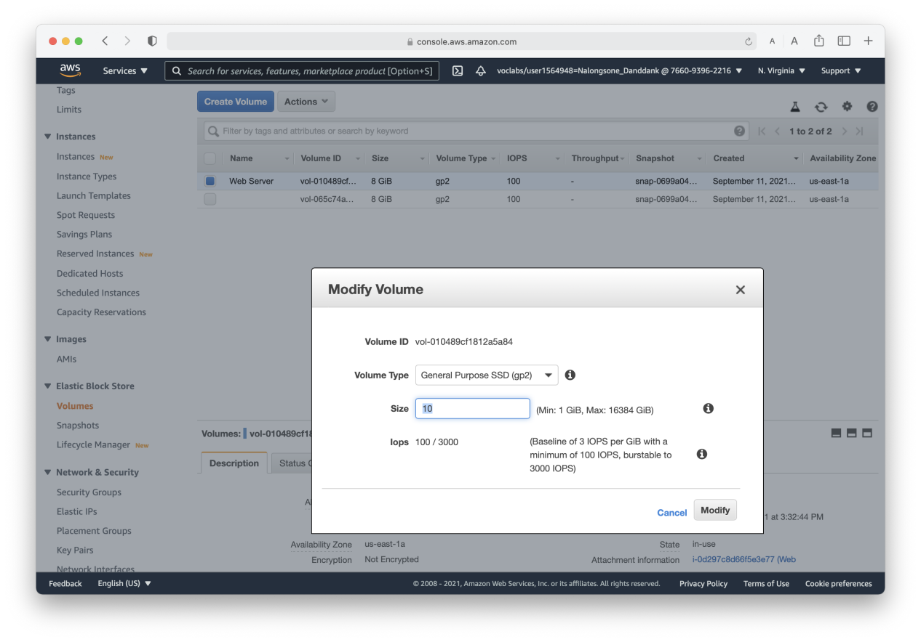

**Lab report screen-shot #6:**

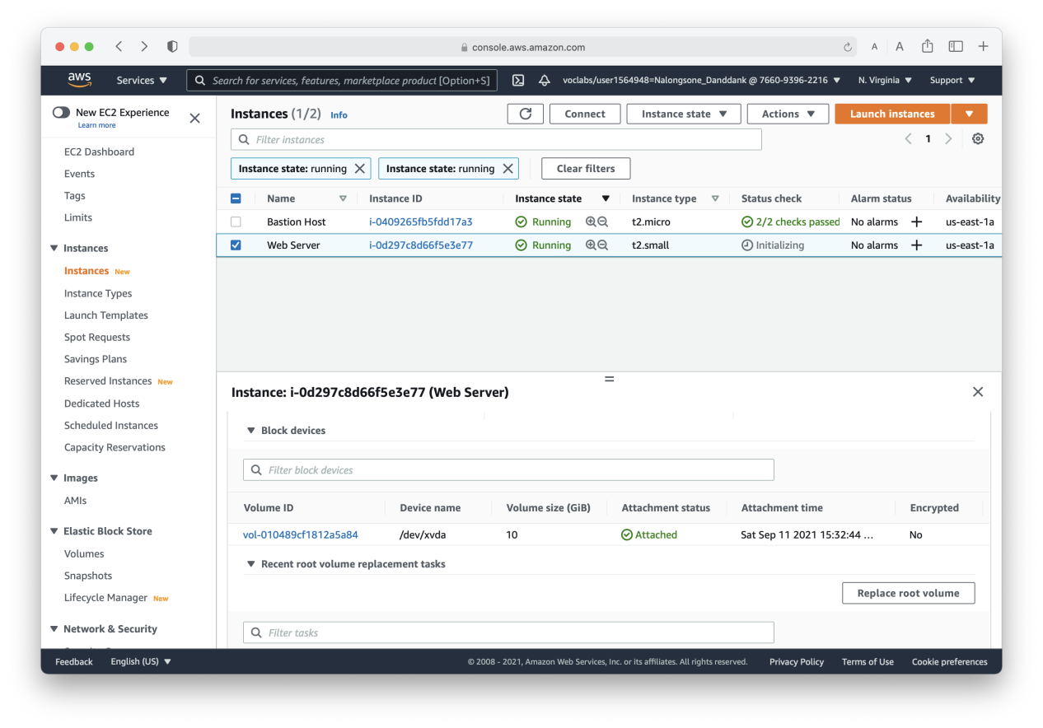

**Lab report screen-shot #7:**

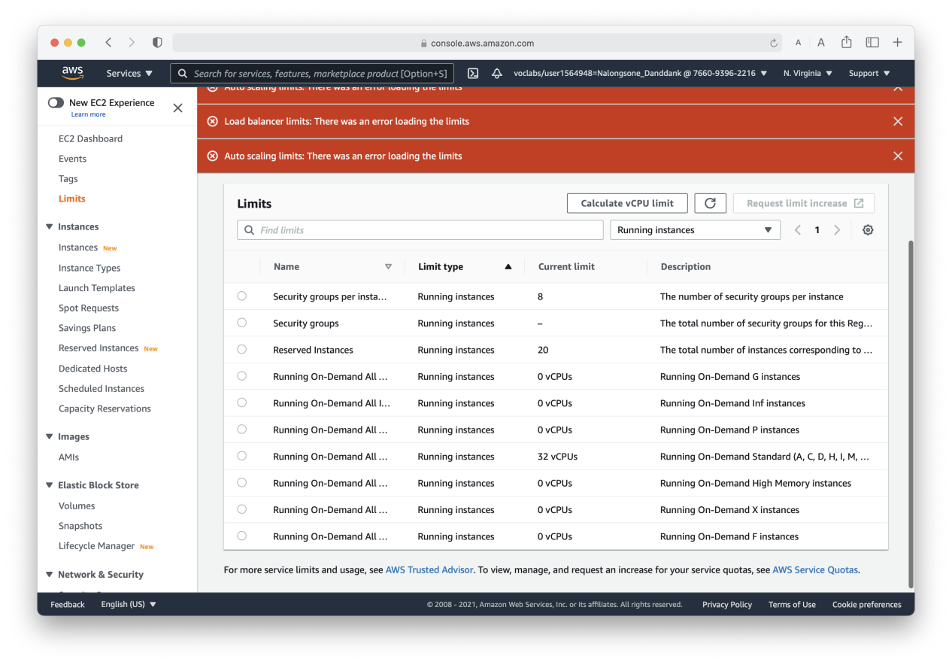

**Lab report screen-shot #8:**

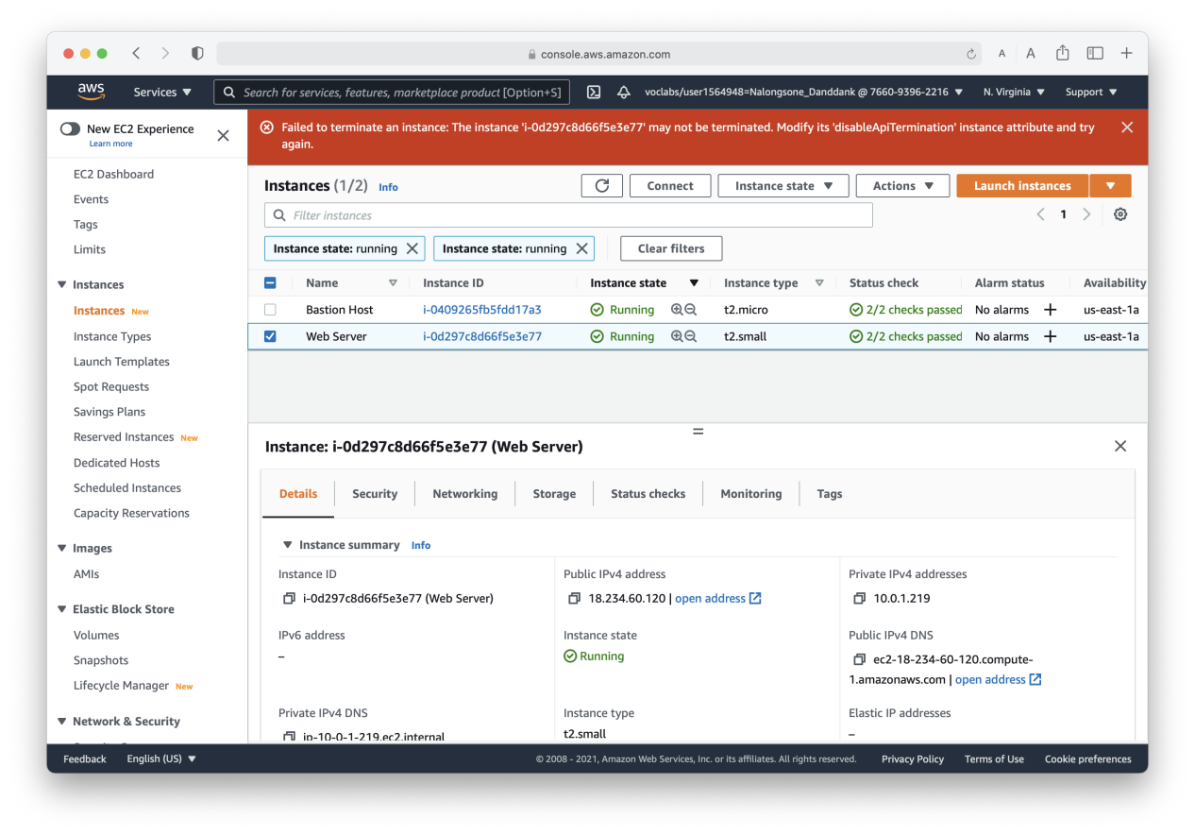

**Lab report screen-shot #9:**

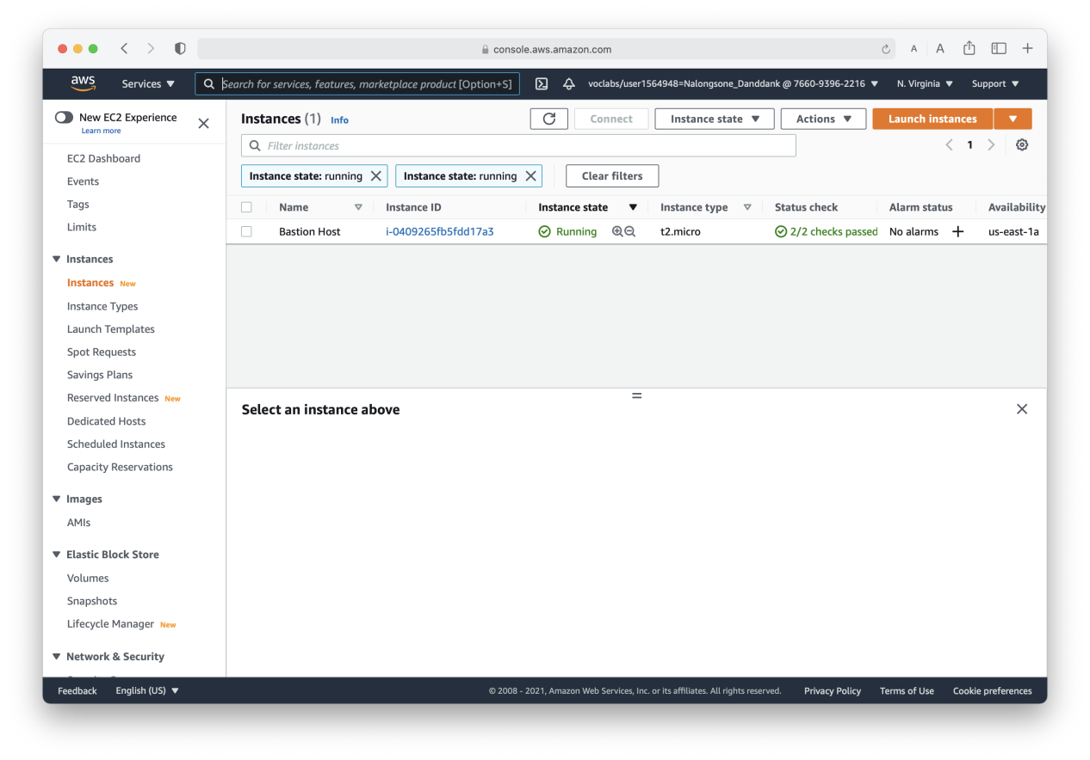

Part 2: GCP.

Exercise 2: Virtual Machines in GCP: Compute Engine.

**Lab report screen-shot #10:**

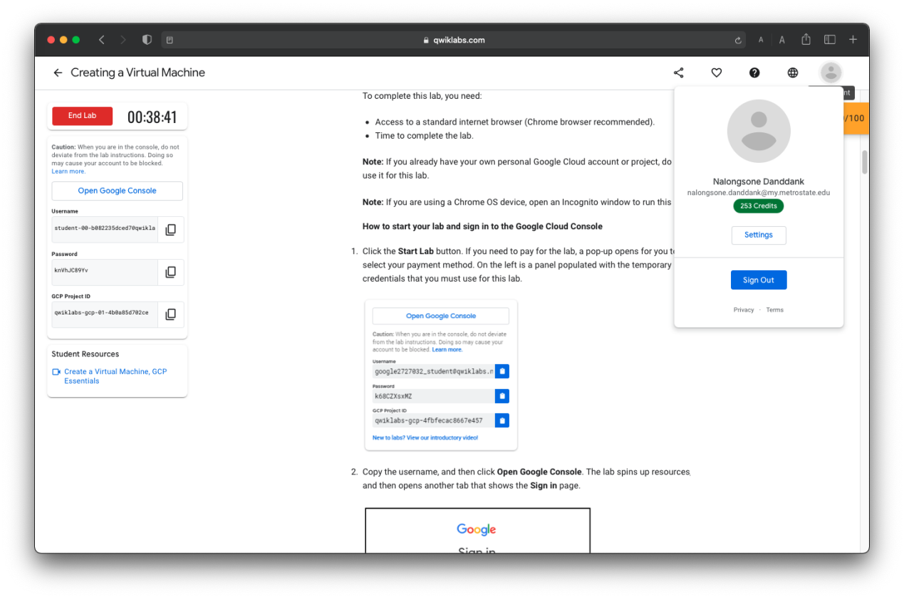

**Lab report screen-shot #11:**

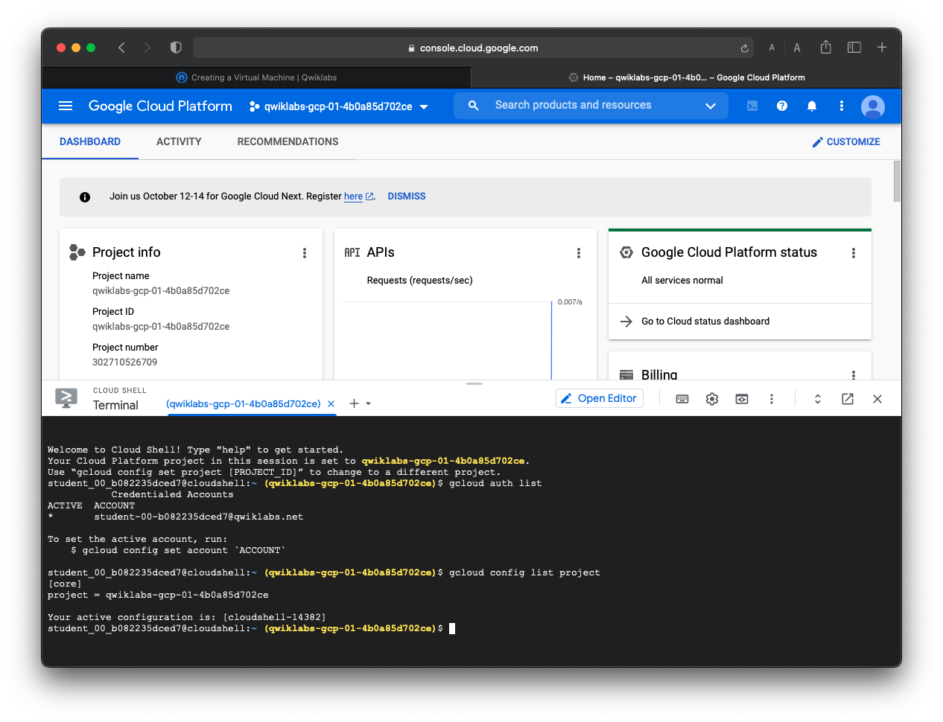

**Lab report screen-shot #12:**

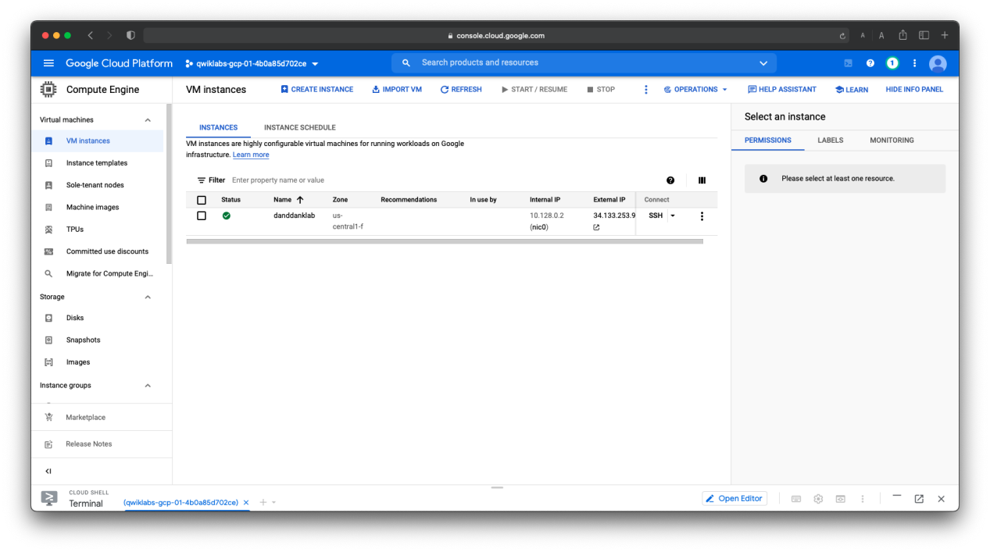

**Lab report screen-shot #13:**

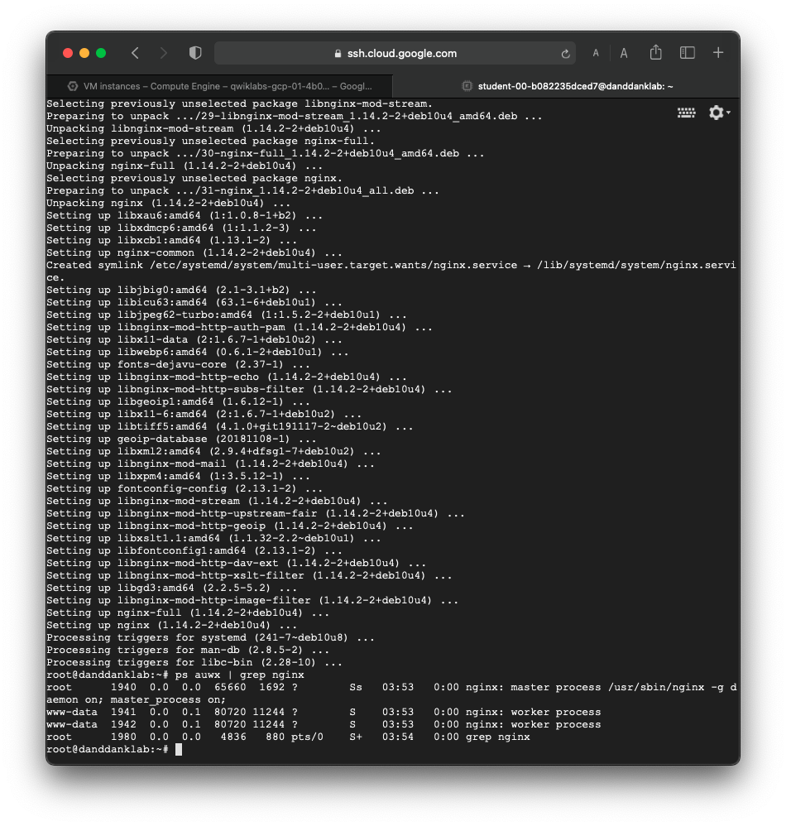

**Lab report screen-shot #14:**

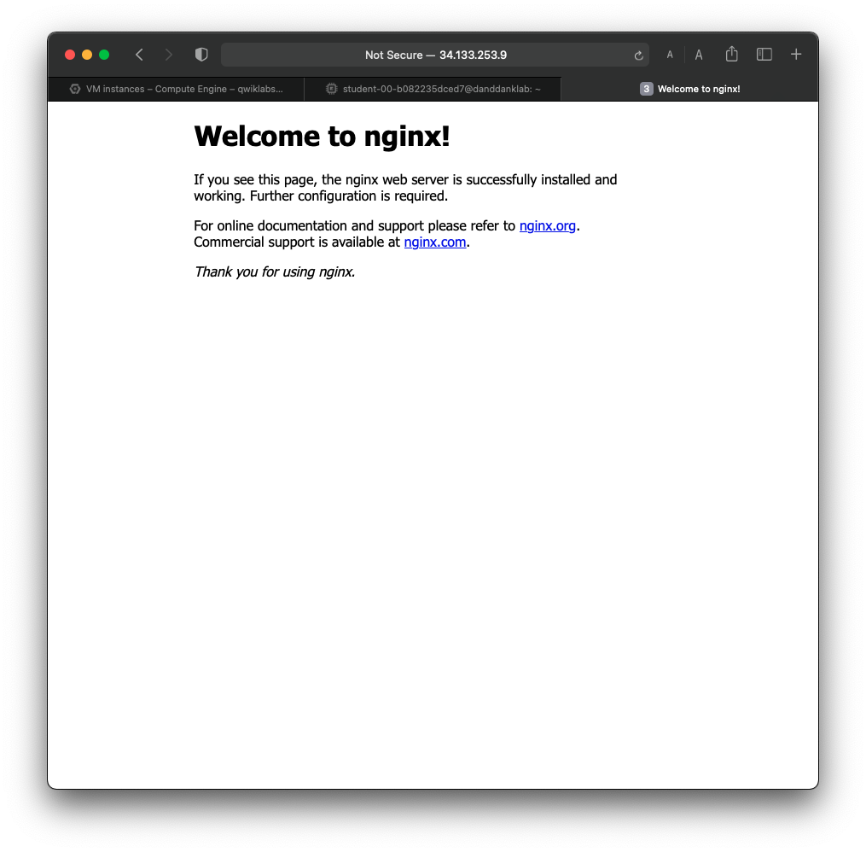

**Lab report screen-shot #15:**

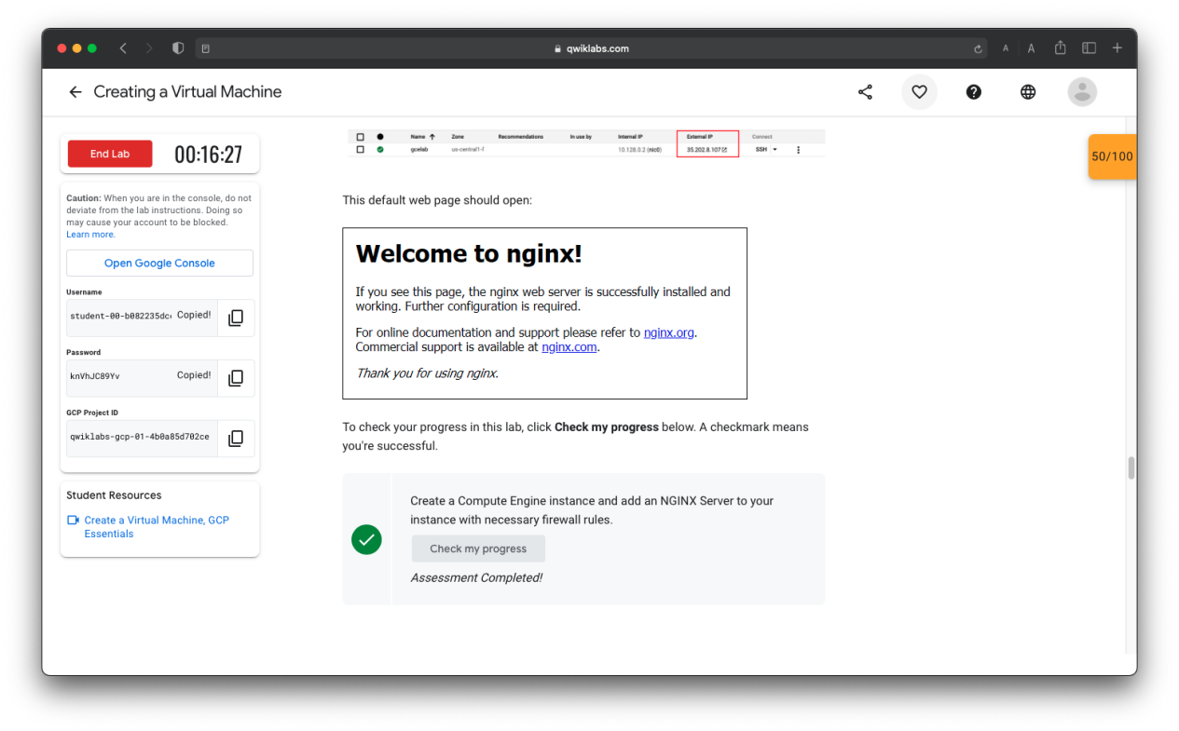

**Lab report screen-shot #16:**

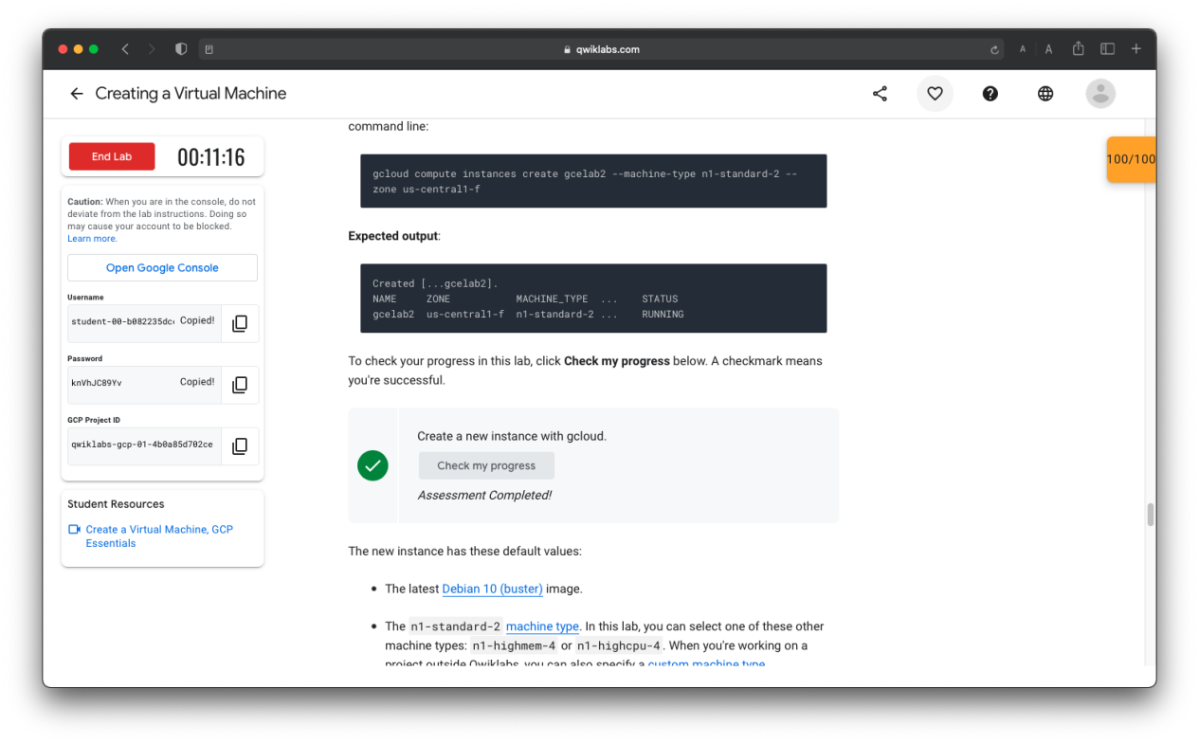

**Lab report screen-shot #17:**

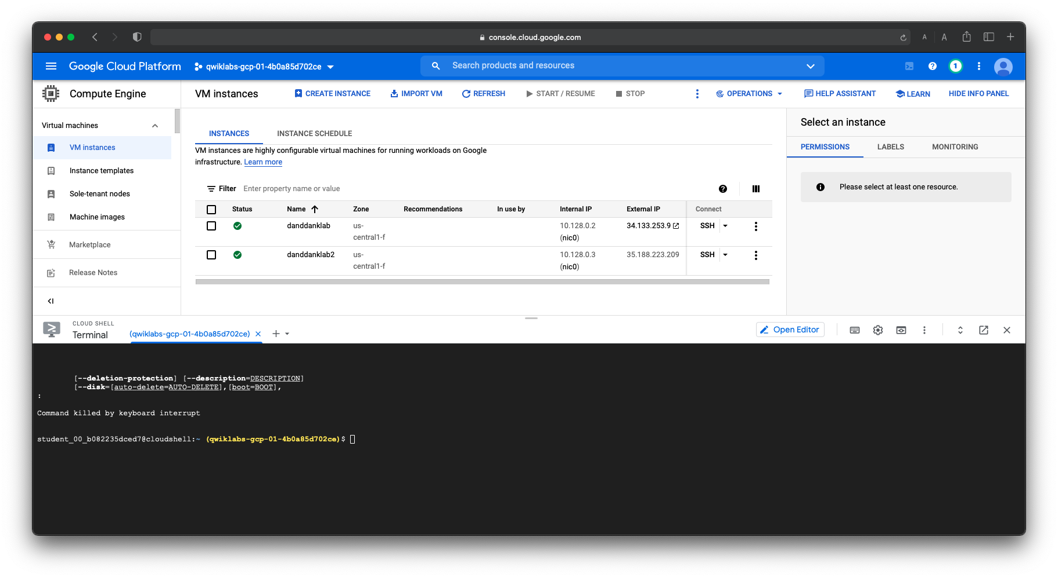

**Lab report screen-shot #18:**

